**CIS Reminder Message - Aurena**

|  |  |  |  |  |
| --- | --- | --- | --- | --- |
| **Ver** | **Date** | **Author** | **Comments** | **Reviewed by** |
| 1 | 12/03/2021 | Tom Bell | CRIM 0606 | TBC |
| 2 | 16/04/2021 | Tom Bell | Error in spec rectified. |  |

Requirements 2

Prerequisites 2

Solution Overview 2

Solution Details 2

Security 3

Companies 3

Data Migration 3

Test Steps 3

Technical Implementation 3

Requirements

When posting a manual supplier invoice with a Supplier that is CIS relevant. A pop up message must appear when a user posts the invoice asking the user to do a final check of the Income Types.

Solution Overview

**Environment:** Aurena

If the Supplier is CIS rated then when posting a Supplier Invoice the system must created a pop up message.

This pop up message will allow a user to go back and change the invoice or proceed to post the invoice.

Solution Details

# Conditions for CRIM – CIS Supplier Tickbox

The below functionality must only take place if a custom tick box (called CIS Supplier) is marked TRUE.

The custom tick box must be called “CIS Supplier” and be located in the red box as per the below screenshot.

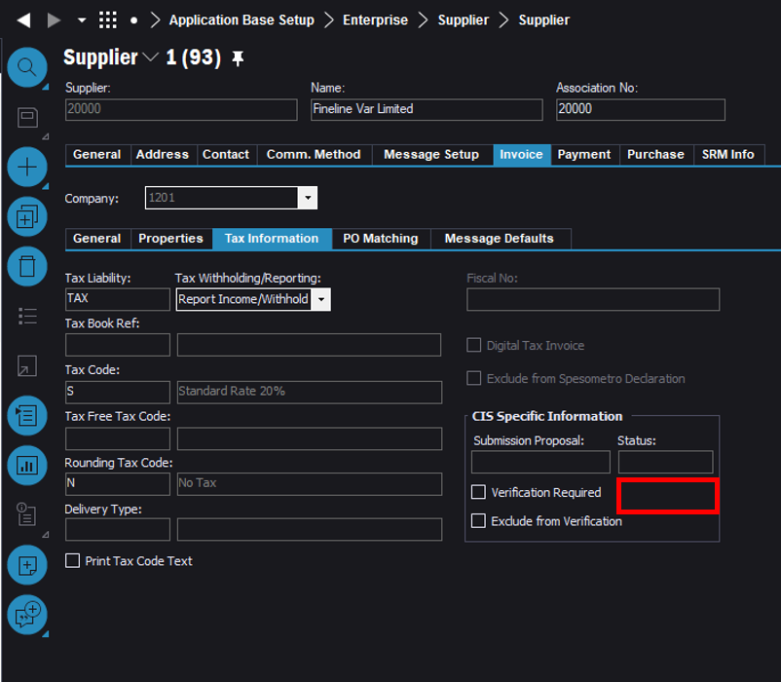

# CRIM Trigger – Manual Supplier Invoice “Finish” button

Within the Aurena, new Manual Supplier Invoice screen. When clicking the “Finish” button in red. Instead of posting the invoice directly. The system must create a pop-up message.

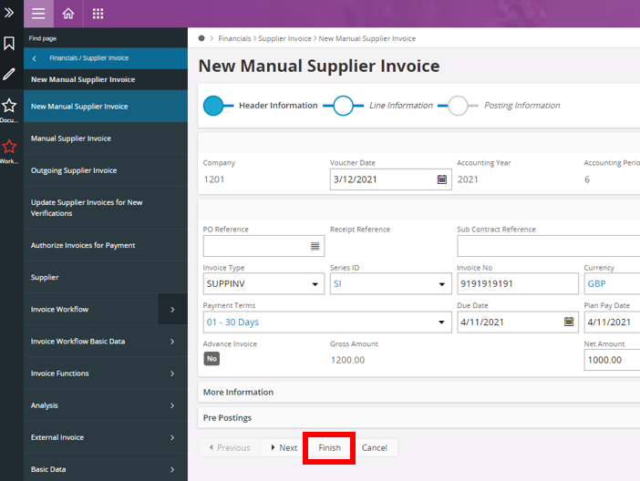

# CRIM Result – Dialogue Box

The dialogue box message must read.

*“CIS Supplier – Please ensure the Income Type for Labour and Material are split correctly.”*

The dialogue box will have two buttons. Once to go back and edit the invoice, the other to post the invoice.

* “FINISH” – Button that posts invoice
* “EDIT INVOICE” – Button that allows a user to go back and edit the invoice. (invoice does not post)

**Technical.**

Field Definitions.

<New Field/CLU Definition>

|  |  |  |  |  |  |  |
| --- | --- | --- | --- | --- | --- | --- |
| New DB Object Name | DB Object Item/Field Names | Item Description | Item Data Type | Item Syntax | Calculation Spec, if Derived | LOVs/Enums/Is Mandatory? |
|  |  |  |  |  |  |  |
|  |  |  |  |  |  |  |
|  |  |  |  |  |  |  |
|  |  |  |  |  |  |  |
|  |  |  |  |  |  |  |
|  |  |  |  |  |  |  |
|  |  |  |  |  |  |  |
|  |  |  |  |  |  |  |
|  |  |  |  |  |  |  |
|  |  |  |  |  |  |  |
|  |  |  |  |  |  |  |
|  |  |  |  |  |  |  |

Security

<Define security controls> (Who needs access to this and will it be restricted from any other users etc)

Auto Populate for All Users.

**Default Advanced Invoice Tax Code Field** - Create, Edit and Delete privileges for Financial Accounts.

Companies

Applies to the following companies. All.

|  |  |
| --- | --- |
| **Company** | **Required (Y/N)** |
| 1201 | Y |
| TBC |  |
|  |  |

Data Migration

<Describe any data migration impacts this development may have – i.e additional data to be migrated>

Test Steps

<Steps that needs to be taken to test this change. Please provide expected results> Updated post solution.

|  |  |  |
| --- | --- | --- |
| **No** | **Script\Test Steps** | **Expected Result** |
| 1 | Go to post a manual supplier invoice with a CIS supplier | See dialogue box that lets user go back and edit the invoice or click “Finish” to post invoice as normal. |
| 2 |  |  |
| 3 |  |  |
| 4 |  |  |
|  |  |  |
|  |  |  |

Technical Implementation

Custom Field **CIS Supplier** is added in the **Supplier** and **Suppliers** Page both in **IEE** and **Aurena**.

1. **Suppliers Page- IEE**

Note – If the Column is not available in the Column Chooser, Reload Configurations while making sure the Custom Field is published and approved. Similarly, the logical unit “Supplier Info General” needs to be approved, published and synchronized.

1. **Suppliers Page- AURENA**

* Go to Suppliers Page 🡪 Page Designer
* In All Elements Section 🡪 LIST 🡪Supplier List 🡪Content 🡪 Add the Custom Field

1. **Supplier Page - IEE**

Note – If the field is not available in the Layout, Reload Configurations, RMB, Properties, Layout, and add the CIS Supplier Custom Field while making sure the it is published and approved.

1. **Supplier Page – Aurena**

* Go to Supplier Page 🡪 Page Designer
* In All Elements Section 🡪 GROUP 🡪Supplier Invoice General Group 🡪Content 🡪 Add the Custom Field

The Custom Event

Custom Event Action

Delivery Notes

* Package - EA_FINANCE
* Permissions Granted – Anyone who have access to the Supplier and Suppliers Page.